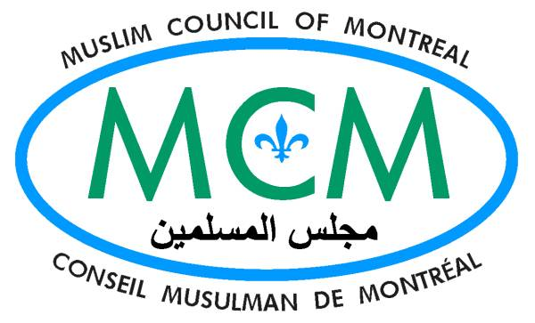

Montreal, December 15th 2005

Mr Gérald Tremblay
Mayor of the city of Montréal
Hôtel de ville
275, rue Notre Dame- Est bureau 1.113

Montréal Qc H2Y 1C6

Re: The death of Mohamed Annas Bennis, who was shot dead by an SPVM police officer on December 1st 2005.

Dear Mayor Tremblay,

I am bringing to your attention the case of Mohamed Annas Bennis who was shot dead by an SPVM police officer on December 1, 2005. After two weeks of his death, neither his relatives nor the Muslim community have any clear information relating to his death.

Mr. Bennis, who was returning from morning prayers when the incident took place, was shot in the shoulder and heart and was pronounced dead on arrival at the Jewish General Hospital. Montreal police says he was carrying a knife and attempted to stab an officer who was present at the scene of an earlier unrelated arrest.

Based on the testimony of those who knew Bennis, he was a pious Muslim with an impeccable reputation, and the police allegations against him are completely incompatible with his personality and character. In light of this, MCM and many members of the community are concerned that Bennis may have been an unfortunate victim of racial profiling or raw racism and, as a result, paid for it with his life.

Please note that I believe that the vast majority of police officers in this city are dedicated to making the streets of Montreal safe and perform an outstanding service. However, if the information transmitted by the police is not true, the action of the officer is proven to be excessive, or there is no quick, impartial and transparent investigation of this incident this would tarnish the reputation of all police officers and would be really unfortunate.

Montreal's Muslim community, and other Montreal communities who suffered racial profiling in the past, are eager to know what really happened as they are very concerned about this incident and, as a consequence, feel less safe on the street's of Montreal.

Furthermore, due to the anger and rage over this incident, if this problem is not addressed soon it would sour the relations between the police and above communities, and it would become instrumental in damaging the social fabric of our city.

Therefore, I recommend the following steps to be acted upon immediately:

- The city must reiterate its commitment to a zero tolerance policy towards racism and racial profiling of any kind within the police force or any other city institution.
- The city must assure the Muslim community that the investigation into Bennis' death will be transparent, independent and done in a timely fashion without any stalling.
- That those who have committed any wrong doing will be held fully accountable for their actions.

The above assurances may be given through a press conference or by a direct letter to the Muslim Council of Montreal, which in turn will announce to the Muslim community and other effected communities. This will also stop a series of actions that may be instrumental in deteriorating the situation further.

If you have any question please do not hesitate to contact the undersigned.

Hoping the above request will meet with your full support, I remain,

Sincerely
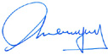
Salam Elmenyawi
President, Muslim Council of Montreal - MCM

CC :
- Mr. Alan DeSousa, Member of the City of Montreal Executive Committee, and Mayor of St-Laurent Borough.

